SCREEN SHOT #1 – DASHBOARD
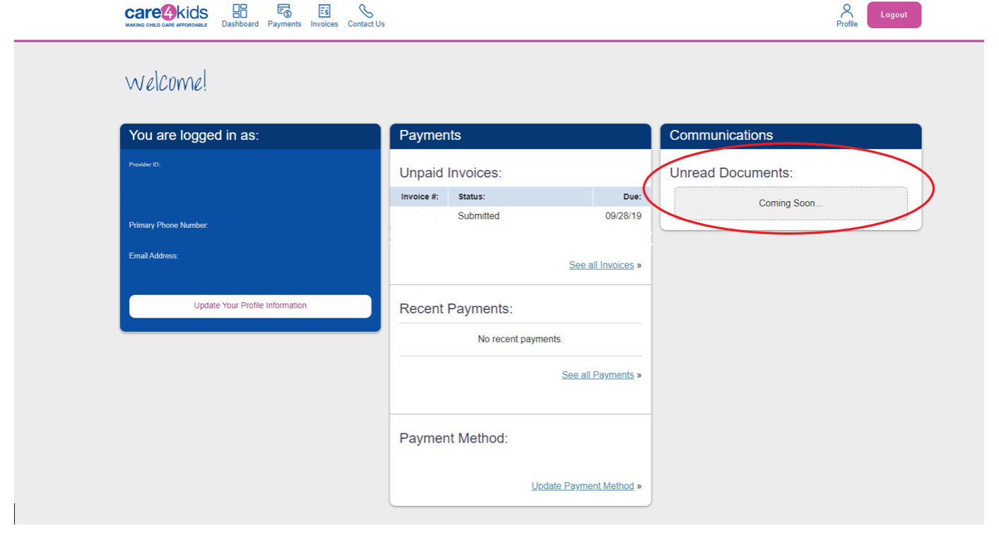

SCREEN SHOT #2 – DASHBOARD / PROFILE
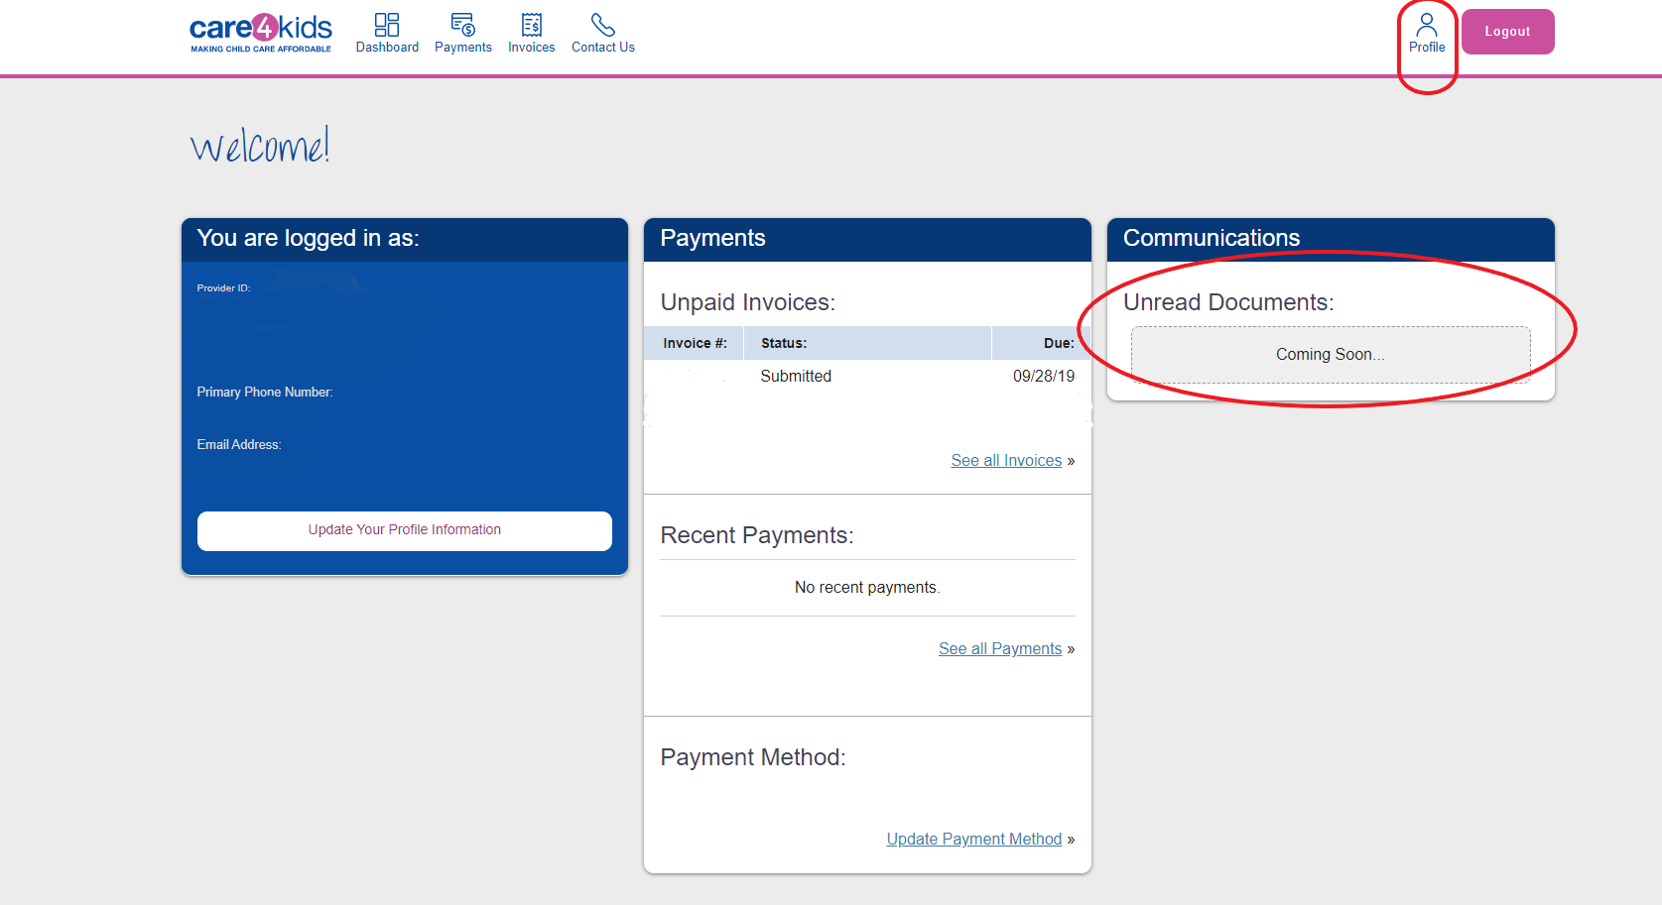

SCREEN SHOT #3 - PROFILE SETTINGS
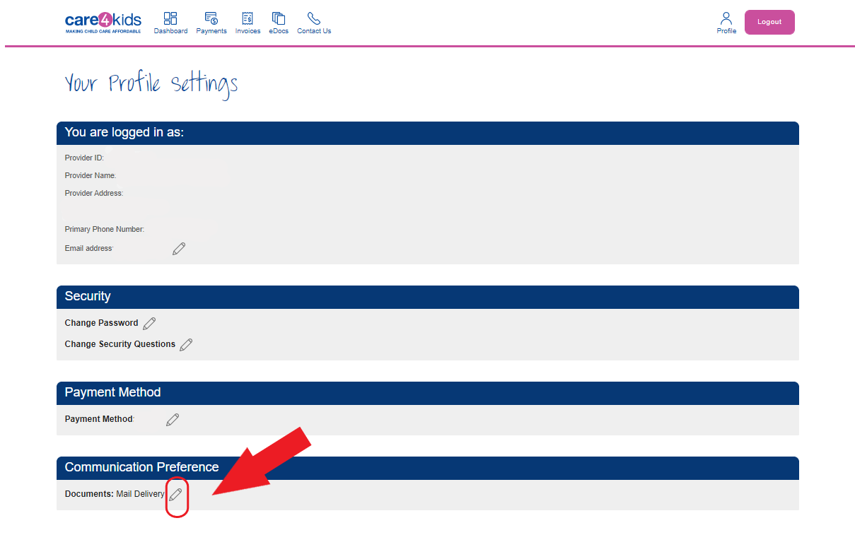
SCREEN SHOT #4 – COMMUNICATION PREFERENCE SELECTION

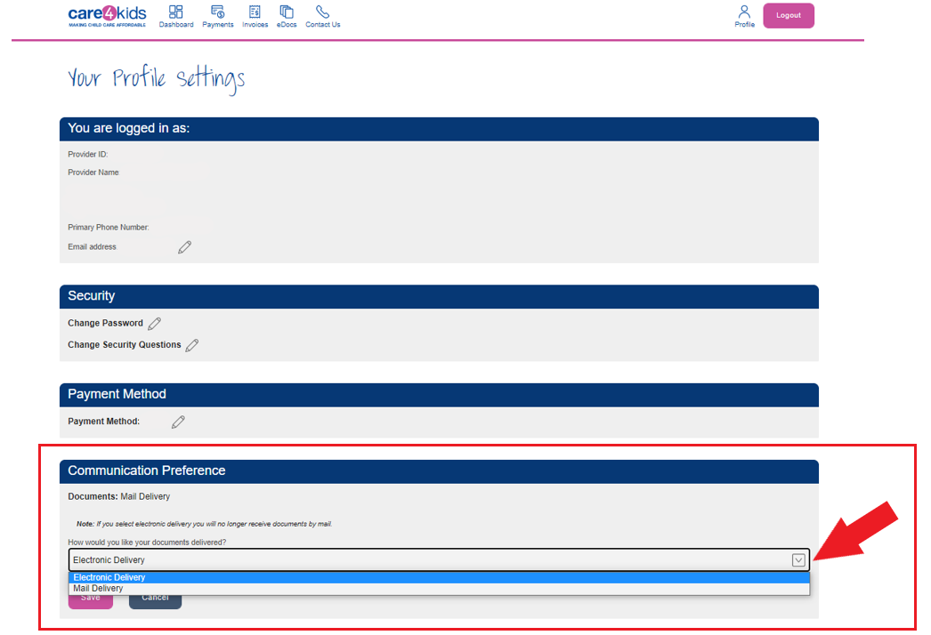

SCREEN SHOT #5 – SAVE COMMUNICATION PREFERENCE
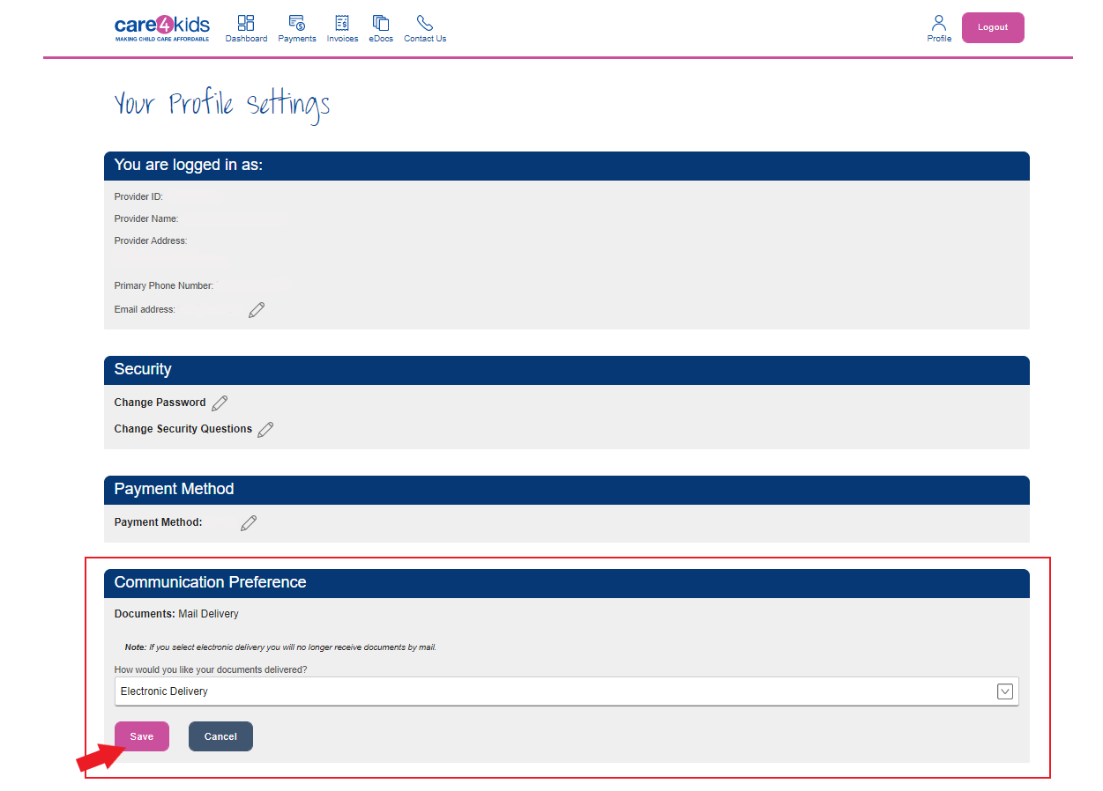

SCREEN SHOT #6 – VALIDATION
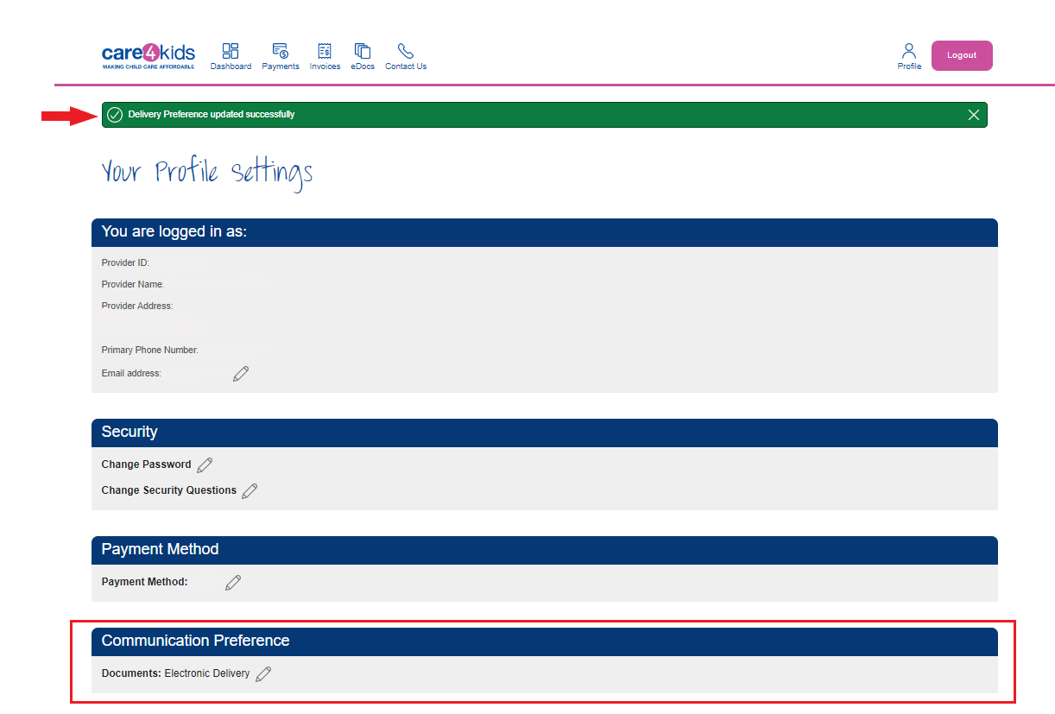

SCREEN SHOT #7 – DOCUMENTS
