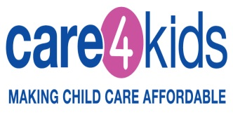
Union Dues Deduction Reimbursement Payment FAQ’s

- Q. Why did I receive new certificates?

- Care 4 Kids computer system upgrades have been completed to allow for payments to be issued at the 2017 reimbursement rates. For home based providers this includes a reduction of 1.5%.

- Q. Why does my certificate reflect 1.5% less than the reimbursement rate?

- This allows for the deduction of union dues for home based providers

- Q. How is the 1.5% calculated using the 2017 reimbursement rates?

- 1.5% is subtracted from the 2017 weekly reimbursement rate rounded down to the next whole dollar due to computer system limitations. This amount is multiplied by 4.3 to equal the monthly reimbursement rate.

- Q. What if too much is withheld in union dues?

- If you are a member of the union whose dues are less than what was deducted, the balance will be reimbursed to you in the following month.

- Q. What if I am not a union member?

- Any amount withheld will be reimbursed to you in the following month.

- Q. Is there any action I need to take?

- No, there is no action required for families or providers.

- Q. How will I receive my dues deduction reimbursement payment?

- Reimbursements will be made using the same method that you have chosen for your monthly payments.

- Q. Do I need to submit an invoice for the dues deduction reimbursement?

- No, all reimbursements will be made automatically by Care 4 Kids in the following month your invoice was paid.

Each month we will update the Processing Status Page on our website with the union dues deduction reimbursement dates.

